**LetsUpgrade (Assignment Submission – Day 1)**

Master Data Structure and Algorithms with C++

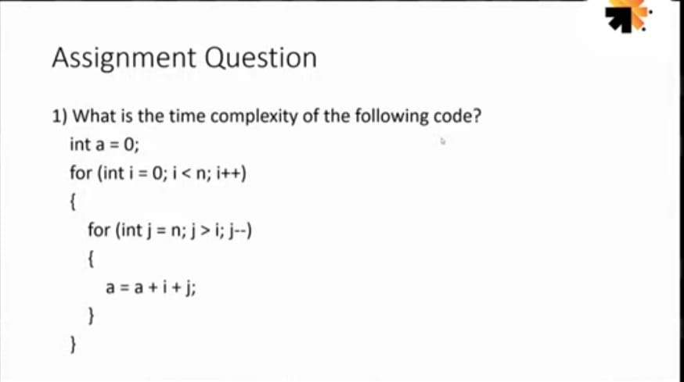

The above code runs total no of times

= N + (N – 1) + (N – 2) + … 1 + 0

= N * (N + 1) / 2

= 1/2 * N^2 + 1/2 * N

O(N^2) times

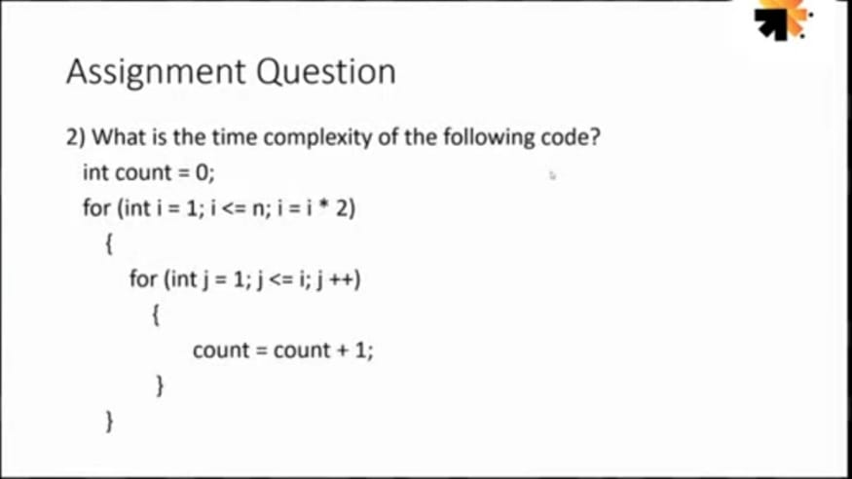 = O(n)

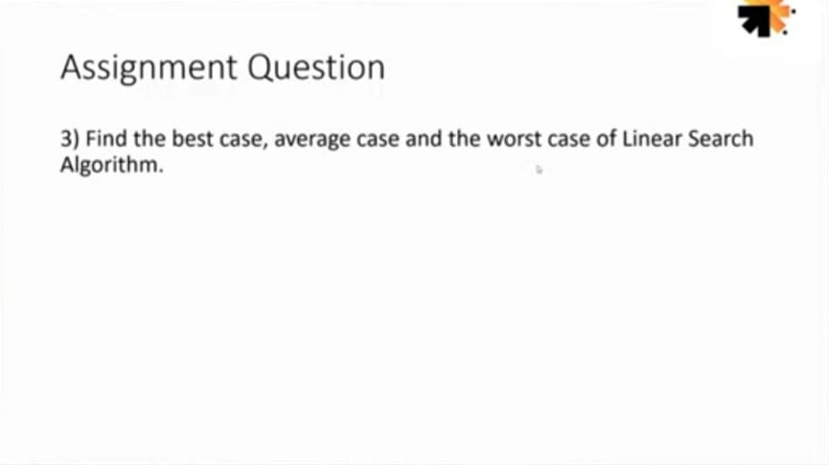 Best Case = O(1), Worst Case = O(n) , Average Case = O(n/2)